**WEEK-2**

**Exercise 1: Control Structures**

**1)** **IF-ELSE**

**CODE:**

SET SERVEROUTPUT ON;

DECLARE

marks NUMBER;

BEGIN

marks := 95;

IF marks >= 90 THEN

DBMS_OUTPUT.PUT_LINE('Grade: A');

ELSIF marks >= 75 THEN

DBMS_OUTPUT.PUT_LINE('Grade: B');

ELSIF marks >= 60 THEN

DBMS_OUTPUT.PUT_LINE('Grade: C');

ELSE

DBMS_OUTPUT.PUT_LINE('Grade: F');

END IF;

END;

/

**OUTPUT:**

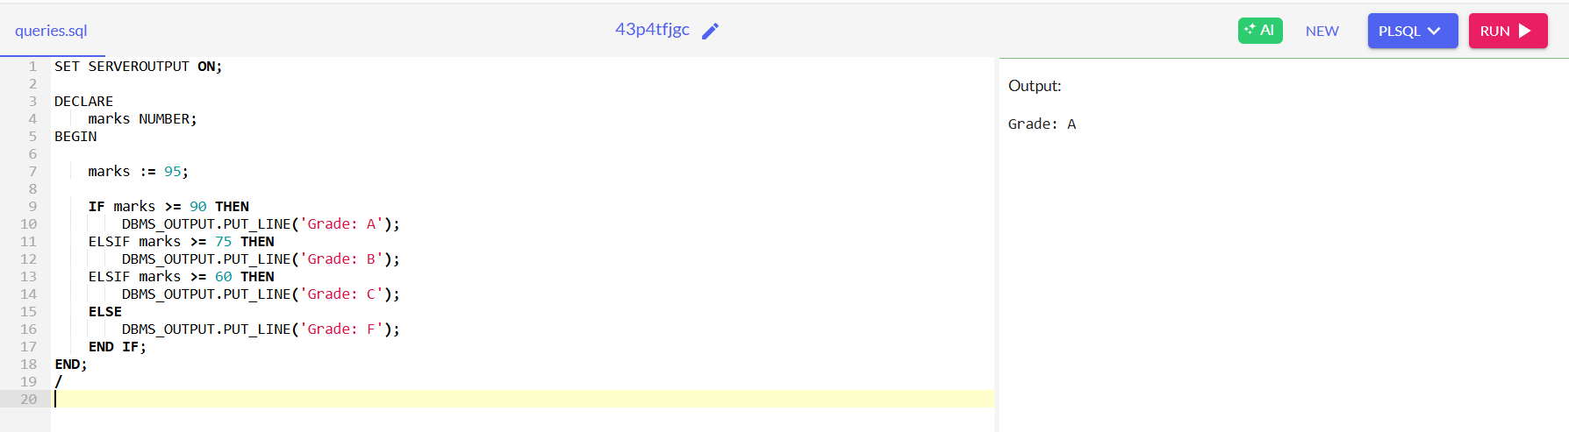

**2)** **CASE Statement**

**CODE:**

DECLARE

dept_id NUMBER := 10;

BEGIN

CASE dept_id

WHEN 10 THEN DBMS_OUTPUT.PUT_LINE('Department: HR');

WHEN 20 THEN DBMS_OUTPUT.PUT_LINE('Department: Finance');

WHEN 30 THEN DBMS_OUTPUT.PUT_LINE('Department: IT');

ELSE DBMS_OUTPUT.PUT_LINE('Unknown Department');

END CASE;

END;

/

**OUTPUT:**

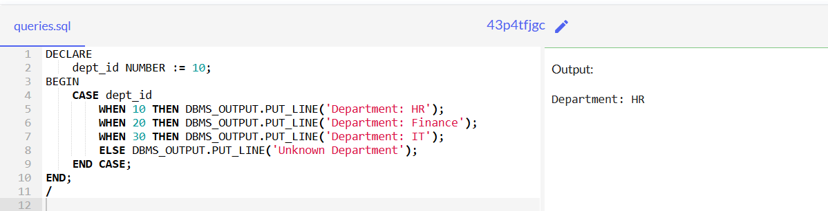

**3)** **WHILE Loop**

**CODE:**

DECLARE

counter NUMBER := 1;

BEGIN

WHILE counter <= 5 LOOP

DBMS_OUTPUT.PUT_LINE('This is PL/SQL: ' || counter);

counter := counter + 1;

END LOOP;

END;

/

**OUTPUT:**

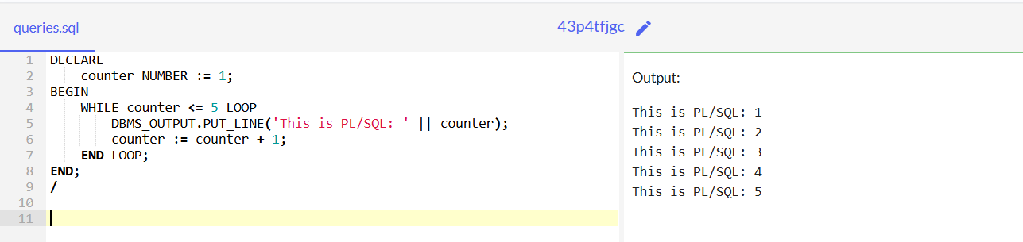

**4)** **FOR Loop**

**CODE:**

BEGIN

FOR i IN 1..7 LOOP

DBMS_OUTPUT.PUT_LINE('Iteration count: ' || i);

END LOOP;

END;

/

**OUTPUT:**

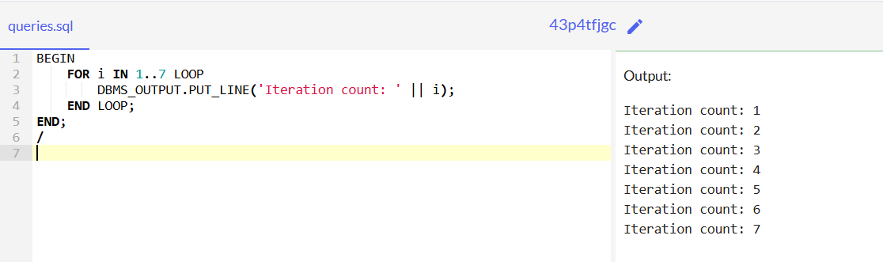

**5)** **EXIT**

**CODE:**

DECLARE

i NUMBER := 1;

BEGIN

LOOP

DBMS_OUTPUT.PUT_LINE('Inside Loop count: ' || i);

IF i = 3 THEN

EXIT;

END IF;

i := i + 1;

END LOOP;

END;

/

**OUTPUT:**

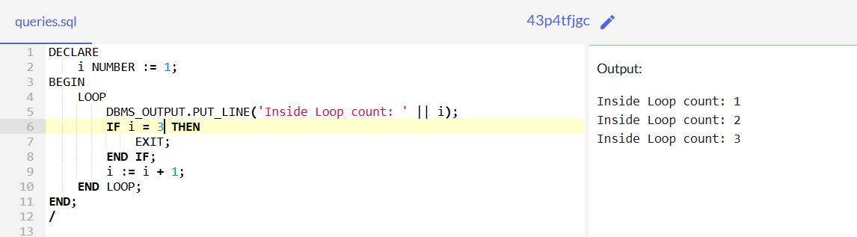

**6)** **CONTINUE**

**CODE:**

BEGIN

FOR i IN 1..5 LOOP

IF i = 3 THEN

CONTINUE;

END IF;

DBMS_OUTPUT.PUT_LINE('Value: ' || i);

END LOOP;

END;

/

**OUTPUT:**

